Sepax Technologies, Inc.
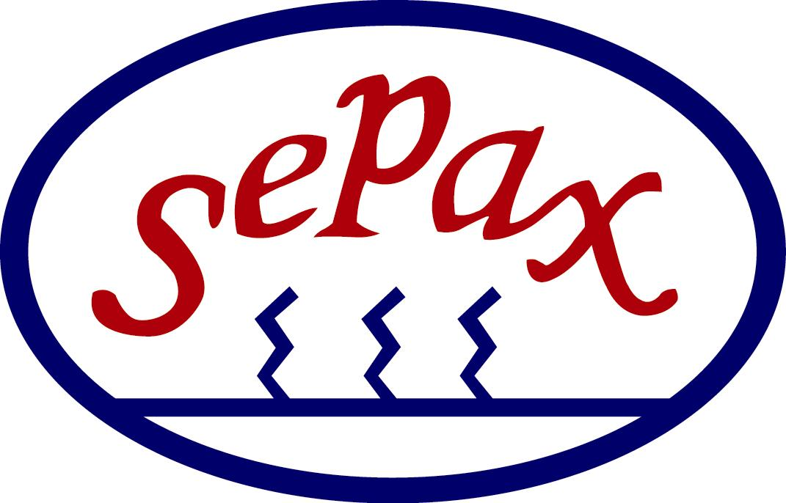
Delaware Technology Park
5 Innovation Way, Suite 100, Newark, DE 19711 USA
Phone: (302) 366-1101 Fax: (302) 366-1151
Toll Free: (877) SEPAX-US
www.sepax-tech.com

Job Title: IT Assistant - P/T
Sepax Technologies, Inc. is currently seeking a highly motivated and talented individual to join and assist our IT team. This individual will work on day-to-day IT support and project activities. This is a part time position based at our headquarter office located in Newark, Delaware near the University of Delaware. Work schedule is 15-25 hours a week from Monday to Friday with a minimum of 3 hours in a day. This is an excellent opportunity for either a sophomore or junior college student looking for industrial experience around their course schedule.

Requirements:
- College student enrolled in a computer related Bachelor degree program
- Must be a current sophomore or junior status
- Diversified technology experience in web technologies, networking and end-user support
- Attention to detail, accuracy and confidentiality
- Organizing and prioritizing skills
- Excellent communication and problem solving skills
- Ability to work in a team environment
- Preferred Languages: HTML, CSS, PHP, JavaScript and SQL

Responsibilities:
- Assist in maintaining the company’s website and intranet
- Assist with the installing, configuring and upgrading computer systems (hardware, operating systems and software)
- Assist in assigning employee accounts
- Assist with other administrative support as needed

Company Overview:
Sepax Technologies, Inc. (www.sepax-tech.com) has emerged as a leader in the area of biological separation. It develops and manufactures cutting-edge liquid chromatography consumables, including LC columns, bulk media, and purification equipment. Sepax owns patented and proprietary resin synthesis and surface coating technologies. Sepax has established itself as a premier US supplier of LC columns and separation media to the biotechnology and pharmaceutical market based on its technology, superior customer service, and technical support.

Sepax Technologies Inc. is an Equal Opportunity Employer.

To Apply:
Please submit your cover letter, resume, class schedule and transcript to hr@sepax-tech.com

